**Q:1) design a simple login page using relative layout.**

**PROGRAM**

**XML**

<?xml version="1.0" encoding="utf-8"?>

<RelativeLayout

    xmlns:android="<http://schemas.android.com/apk/res/android>"

    xmlns:tools="<http://schemas.android.com/tools>"

    android:id="@+id/activity_main"

    android:layout_width="match_parent"

    android:layout_height="match_parent"

    android:background="#00CC99">

    <EditText

        android:id="@+id/text1"

        android:hint="Username"

        android:layout_width="match_parent"

        android:layout_height="wrap_content"

        android:layout_marginTop="150dp"

        android:layout_marginLeft="18dp"

        android:layout_marginRight="18dp"

        android:padding="8dp"

        android:background="#fff" />

    <EditText

        android:id="@+id/text2"

        android:layout_width="match_parent"

        android:layout_height="wrap_content"

        android:layout_marginLeft="18dp"

        android:layout_marginRight="18dp"

        android:padding="8dp"

        android:background="#fff"

        android:hint="Password"

        android:layout_marginTop="12dp"

        android:layout_below="@+id/text1" />

    <Button

        android:id="@+id/b1"

        android:layout_width="match_parent"

        android:layout_height="wrap_content"

        android:text="Login"

        android:textColor="#00CC99"

        android:layout_below="@+id/text2"

        android:layout_marginTop="17dp"

        android:layout_alignStart="@+id/text2"

        android:layout_alignEnd="@+id/text2" />

    <TextView

        android:layout_width="wrap_content"

        android:layout_height="wrap_content"

        android:id="@+id/text3"

        android:textColor="#fff"

        android:text="Not a member?Sign up now"

        android:layout_below="@+id/b1"

        android:layout_centerHorizontal="true"

        android:layout_marginTop="34dp" />

</RelativeLayout>

**JAVA**

package com.codedost.loginscreen;

import android.support.v7.app.AppCompatActivity;

import android.os.Bundle;

public class MainActivity extends AppCompatActivity {

    @Override

    protected void onCreate(Bundle savedInstanceState) {

        super.onCreate(savedInstanceState);

        setContentView(R.layout.activity_main);

    }

}

**OUTPUT**

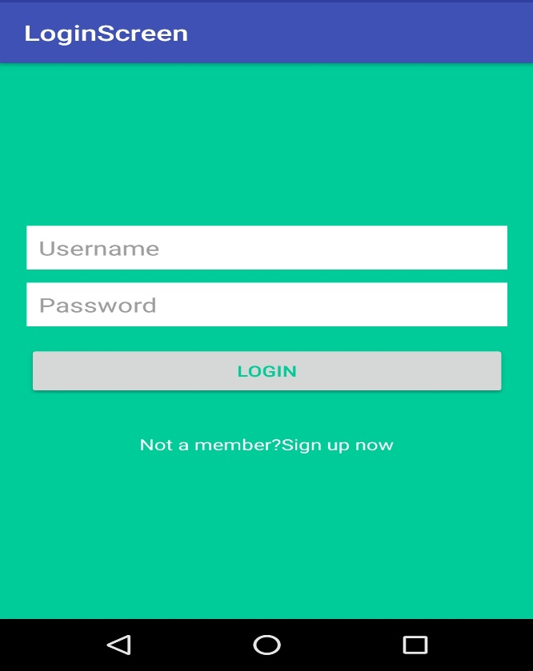

**Q:2) array adapter using list view**

**PROGRAM**

**XML**

<?xml version="1.0" encoding="utf-8"?>

<RelativeLayout

xmlns:android="http://schemas.android.com/apk/res/android"

xmlns:tools="http://schemas.android.com/tools"

android:layout_width="match_parent"

android:layout_height="match_parent"

tools:context=".MainActivity">

<ListView

android:id="@+id/simpleListView"

android:layout_width="match_parent"

android:layout_height="wrap_content" />

</RelativeLayout>

**XML**

**<?xml version="1.0" encoding="utf-8"?>**

<LinearLayout

xmlns:android="http://schemas.android.com/apk/res/android"

android:layout_width="match_parent"

android:layout_height="match_parent"

android:orientation="vertical">

<TextView

android:id="@+id/itemTextView"

android:layout_width="match_parent"

android:layout_height="wrap_content"

android:layout_gravity="center" />

</LinearLayout>

**JAVA**

import android.os.Bundle;

import android.widget.ArrayAdapter;

import android.widget.ListView;

import androidx.appcompat.app.AppCompatActivity;

public class MainActivity extends AppCompatActivity {

ListView simpleListView;

// array objects

String courseList[] = {"C-Programming", "Data Structure", "Database", "Python",

"Java", "Operating System", "Compiler Design", "Android Development"};

@Override

protected void onCreate(Bundle savedInstanceState) {

super.onCreate(savedInstanceState);

setContentView(R.layout.activity_main);

simpleListView = (ListView) findViewById(R.id.simpleListView);

ArrayAdapter<String> arrayAdapter = new ArrayAdapter<String>(this,

R.layout.item_view, R.id.itemTextView, courseList);

simpleListView.setAdapter(arrayAdapter);

}

}

**OUTPUT**

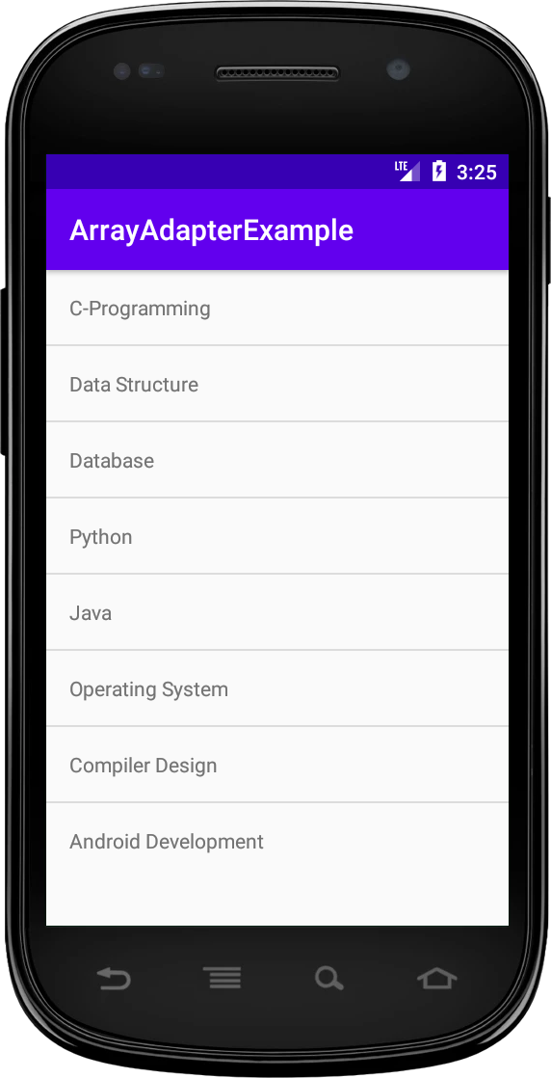

**Q:3) develop an application that toggle image using frame format.**

**PROGRAM**

**.xml**

<FrameLayout xmlns:android="http://schemas.android.com/apk/res/android"

android:layout_width="fill_parent"

android:layout_height="fill_parent">

<ImageView

android:id="@+id/imageview"

android:layout_width="fill_parent"

android:layout_height="fill_parent"

android:scaleType="fitCenter"

android:src="@drawable/piq1" />

<Button

android:id="@+id/next"

android:layout_width="wrap_content"

android:layout_height="30dp"

android:layout_marginBottom="15dp"

android:layout_marginRight="10dp"

android:layout_gravity="bottom|right"

android:paddingTop="2dp"

android:paddingBottom="2dp"

android:background="@drawable/buttonback"

android:textColor="#000000"

android:text="Next" />

</FrameLayout>

**.java**

import android.app.Activity;

import android.os.Bundle;

import android.view.View;

import android.widget.Button;

import android.widget.ImageView;

public class Piqlout extends Activity {

@Override

protected void onCreate(Bundle savedInstanceState) {

// TODO Auto-generated method stub

super.onCreate(savedInstanceState);

setContentView(R.layout.piq);

Button next= (Button) findViewById(R.id.next);

if (next.getText().equals("Next")) {

next.setOnClickListener(new View.OnClickListener() {

@Override

public void onClick(View v) {

// TODO Auto-generated method stub

ImageView img = (ImageView) findViewById(R.id.imageview);

img.setImageResource(R.drawable.piq2);

Button next= (Button) findViewById(R.id.next);

next.setText("Prev");

}

});

}

if (next.getText().equals("Prev")){

next.setOnClickListener(new View.OnClickListener() {

@Override

public void onClick(View v) {

// TODO Auto-generated method stub

ImageView img = (ImageView) findViewById(R.id.imageview);

img.setImageResource(R.drawable.piq1);

Button next= (Button) findViewById(R.id.next);

next.setText("Next");

}

});

}

}

**OUTPUT**

**Q:4) demonstrate activity life cycle.**

**PROGRAM**

**JAVA**

import android.support.v7.app.AppCompatActivity;

import android.os.Bundle;

import android.widget.Toast;

public class MainActivity extends AppCompatActivity {

@Override

protected void onCreate(Bundle savedInstanceState)

{

super.onCreate(savedInstanceState);

// Bundle containing previous frozen state

setContentView(R.layout.activity_main);

// The content view pointing to the id of layout

// in the file activity_main.xml

Toast toast = Toast.makeText(getApplicationContext(), "onCreate Called", Toast.LENGTH_LONG).show();

}

}

**onStart()**

import android.support.v7.app.AppCompatActivity;

import android.os.Bundle;

import android.widget.Toast;

public class MainActivity extends AppCompatActivity {

@Override

protected void onCreate(Bundle savedInstanceState)

{

super.onCreate(savedInstanceState);

// Bundle containing previous frozen state

setContentView(R.layout.activity_main);

// The content view pointing to the id of layout

// in the file activity_main.xml

Toast toast = Toast.makeText(getApplicationContext(), "onCreate Called", Toast.LENGTH_LONG).show();

}

protected void onStart()

{

// It will show a message on the screen

// then onStart is invoked

Toast toast = Toast.makeText(getApplicationContext(), "onStart Called", Toast.LENGTH_LONG).show();

}

}

### ****. onRestart()****

### import android.support.v7.app.AppCompatActivity;

### import android.os.Bundle;

### import android.widget.Toast;

### public class MainActivity extends AppCompatActivity {

### @Override

### protected void onCreate(Bundle savedInstanceState) {

### super.onCreate(savedInstanceState);

### 

### // Bundle containing previous frozen state

### setContentView(R.layout.activity_main);

### 

### // The content view pointing to the id of layout

### // in the file activity_main.xml

### Toast toast = Toast.makeText(getApplicationContext(), "onCreate Called", Toast.LENGTH_LONG).show();

### }

### protected void onRestart() {

### // It will show a message on the screen

### // then onRestart is invoked

### Toast toast = Toast.makeText(getApplicationContext(), "onRestart Called", Toast.LENGTH_LONG).show();

### }

### }

### ****onResume()****

import android.support.v7.app.AppCompatActivity;

import android.os.Bundle;

import android.widget.Toast;

import com.example.share.R;

public class MainActivity extends AppCompatActivity {

@Override

protected void onCreate(Bundle savedInstanceState) {

// Bundle containing previous frozen state

super.onCreate(savedInstanceState);

// The content view pointing to the id of layout

// in the file activity_main.xml

setContentView(R.layout.activity_main);

Toast toast = Toast.makeText(getApplicationContext(), "onCreate Called", Toast.LENGTH_LONG).show();

}

protected void onResume() {

// It will show a message on the screen

// then onResume is invoked

Toast toast = Toast.makeText(getApplicationContext(), "onResume Called", Toast.LENGTH_LONG).show();

}

}

### *****onPause*()****

### import android.support.v7.app.AppCompatActivity;

### import android.os.Bundle;

### import android.widget.Toast;

### public class MainActivity extends AppCompatActivity {

### @Override

### protected void onCreate(Bundle savedInstanceState) {

### // Bundle containing previous frozen state

### super.onCreate(savedInstanceState);

### // The content view pointing to the id of layout

### // in the file activity_main.xml

### setContentView(R.layout.activity_main);

### Toast toast = Toast.makeText(getApplicationContext(), "onCreate Called", Toast.LENGTH_LONG).show();

### }

### protected void onPause() {

### // It will show a message on the screen

### // then onPause is invoked

### Toast toast = Toast.makeText(getApplicationContext(), "onPause Called", Toast.LENGTH_LONG).show();

### }

### }

### ****onStop()****

### import android.support.v7.app.AppCompatActivity;

### import android.os.Bundle;

### import android.widget.Toast;

### public class MainActivity extends AppCompatActivity {

### @Override

### protected void onCreate(Bundle savedInstanceState) {

### // Bundle containing previous frozen state

### super.onCreate(savedInstanceState);

### // The content view pointing to the id of layout

### // in the file activity_main.xml

### setContentView(R.layout.activity_main);

### Toast toast = Toast.makeText(getApplicationContext(), "onCreate Called", Toast.LENGTH_LONG).show();

### }

### protected void onStop() {

### // It will show a message on the screen

### // then onStop is invoked

### Toast toast = Toast.makeText(getApplicationContext(), "onStop Called", Toast.LENGTH_LONG).show();

### }

### }

### ****onDestroy()****

import android.support.v7.app.AppCompatActivity;

import android.os.Bundle;

import android.widget.Toast;

public class MainActivity extends AppCompatActivity {

@Override

protected void onCreate(Bundle savedInstanceState) {

// Bundle containing previous frozen state

super.onCreate(savedInstanceState);

// The content view pointing to the id of layout

// in the file activity_main.xml

setContentView(R.layout.activity_main);

Toast toast = Toast.makeText(getApplicationContext(), "onCreate Called", Toast.LENGTH_LONG).show();

}

protected void onDestroy() {

// It will show a message on the screen

// then onDestroy is invoked

Toast toast = Toast.makeText(getApplicationContext(), "onDestroy Called", Toast.LENGTH_LONG).show();

}

}

JAVA

import android.support.v7.app.AppCompatActivity;

import android.os.Bundle;

import android.widget.Toast;

public class MainActivity extends AppCompatActivity {

@Override

protected void onCreate(Bundle savedInstanceState) {

super.onCreate(savedInstanceState);

setContentView(R.layout.activity_main);

Toast toast = Toast.makeText(getApplicationContext(), "onCreate Called", Toast.LENGTH_LONG).show();

}

protected void onStart() {

super.onStart();

Toast toast = Toast.makeText(getApplicationContext(), "onStart Called", Toast.LENGTH_LONG).show();

}

@Override

protected void onRestart() {

super.onRestart();

Toast toast = Toast.makeText(getApplicationContext(), "onRestart Called", Toast.LENGTH_LONG).show();

}

protected void onPause() {

super.onPause();

Toast toast = Toast.makeText(getApplicationContext(), "onPause Called", Toast.LENGTH_LONG).show();

}

protected void onResume() {

super.onResume();

Toast toast = Toast.makeText(getApplicationContext(), "onResume Called", Toast.LENGTH_LONG).show();

}

protected void onStop() {

super.onStop();

Toast toast = Toast.makeText(getApplicationContext(), "onStop Called", Toast.LENGTH_LONG).show();

}

protected void onDestroy() {

super.onDestroy();

Toast toast = Toast.makeText(getApplicationContext(), "onDestroy Called", Toast.LENGTH_LONG).show();

}

}

**OUTPUT**

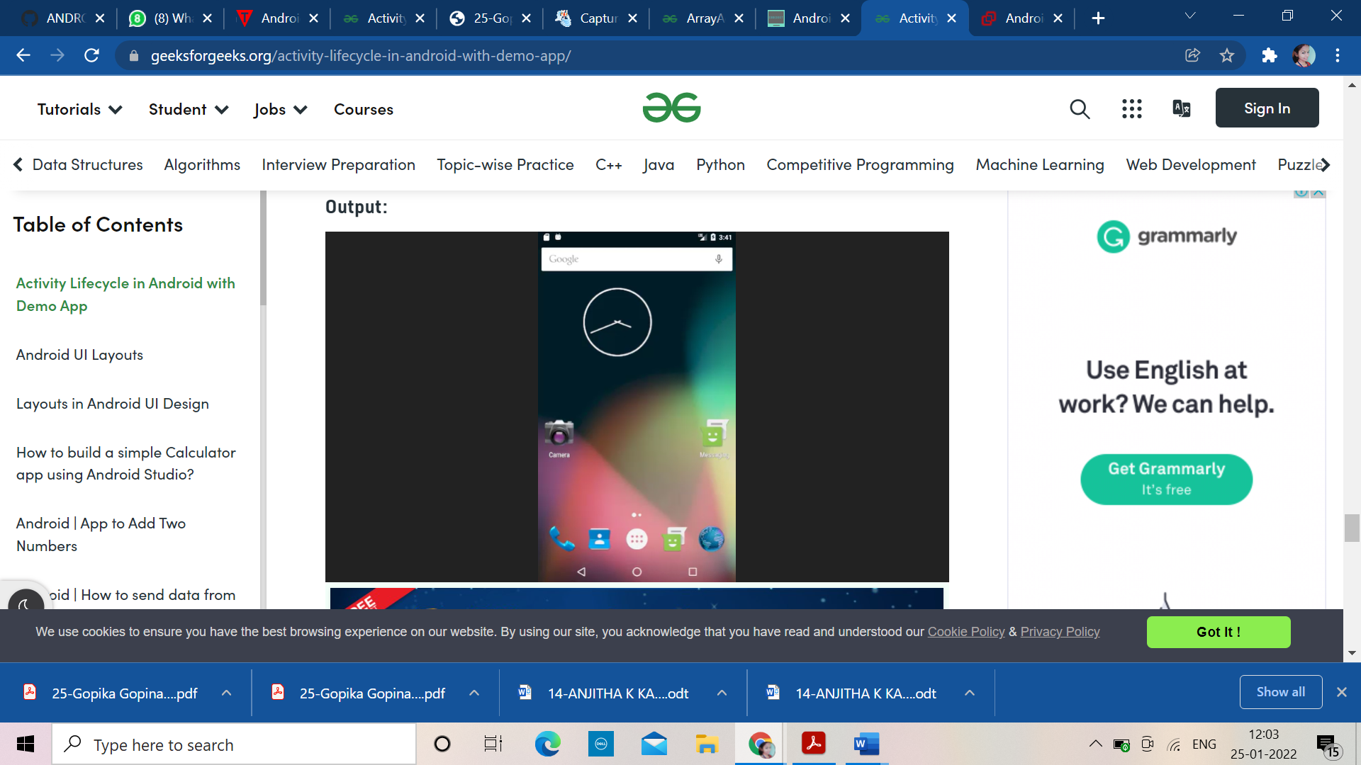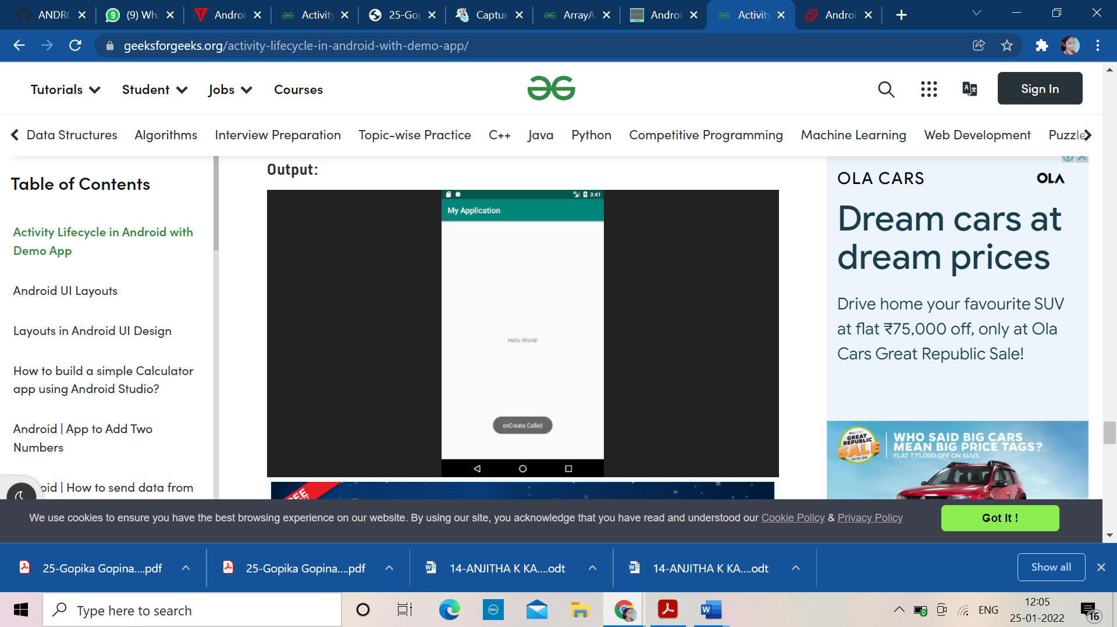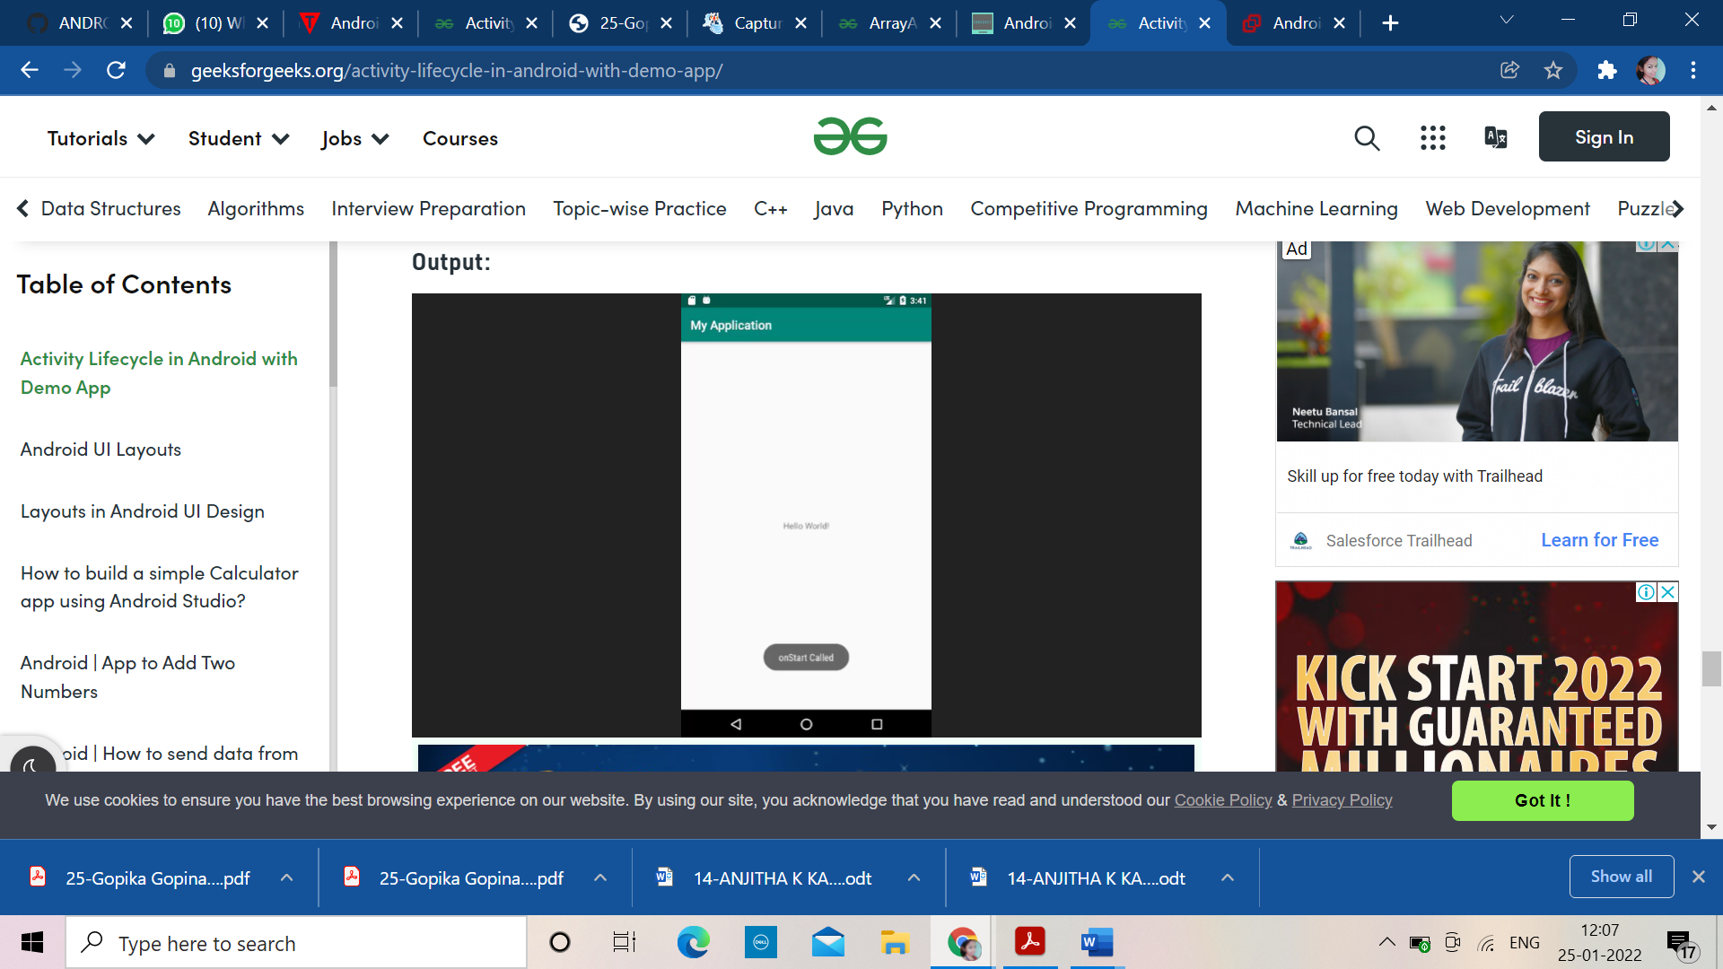

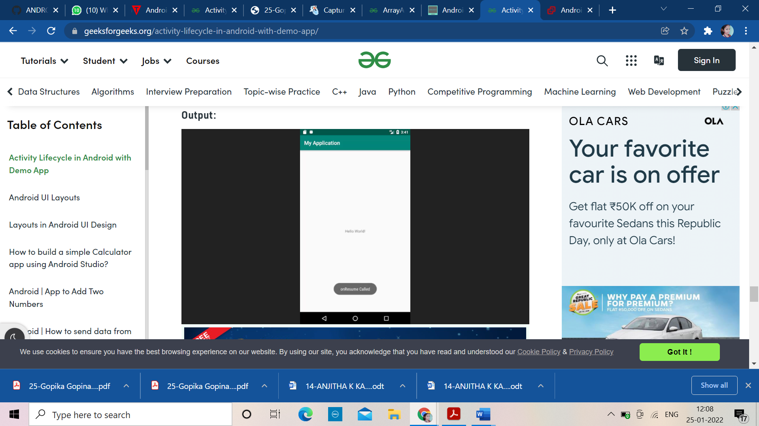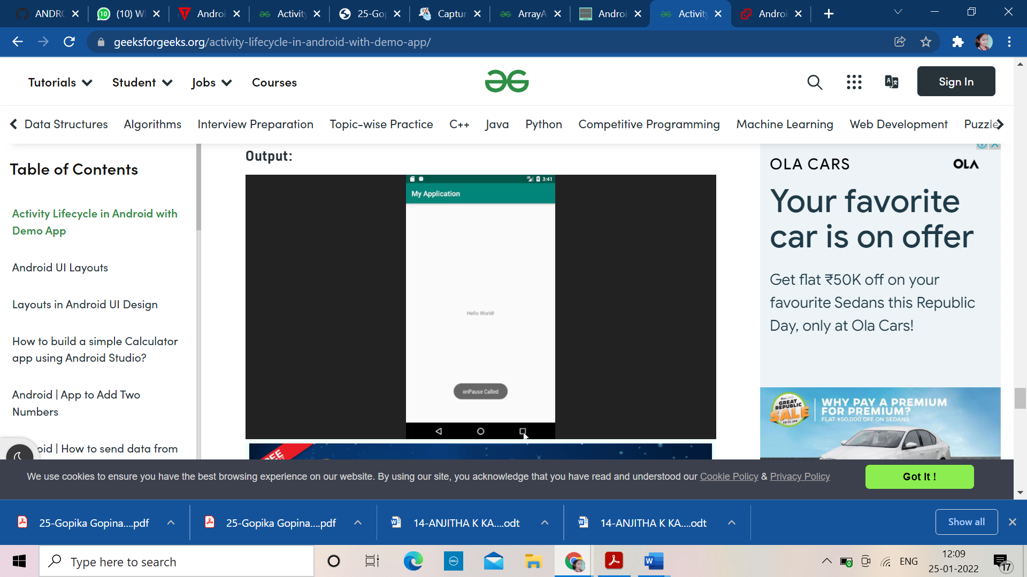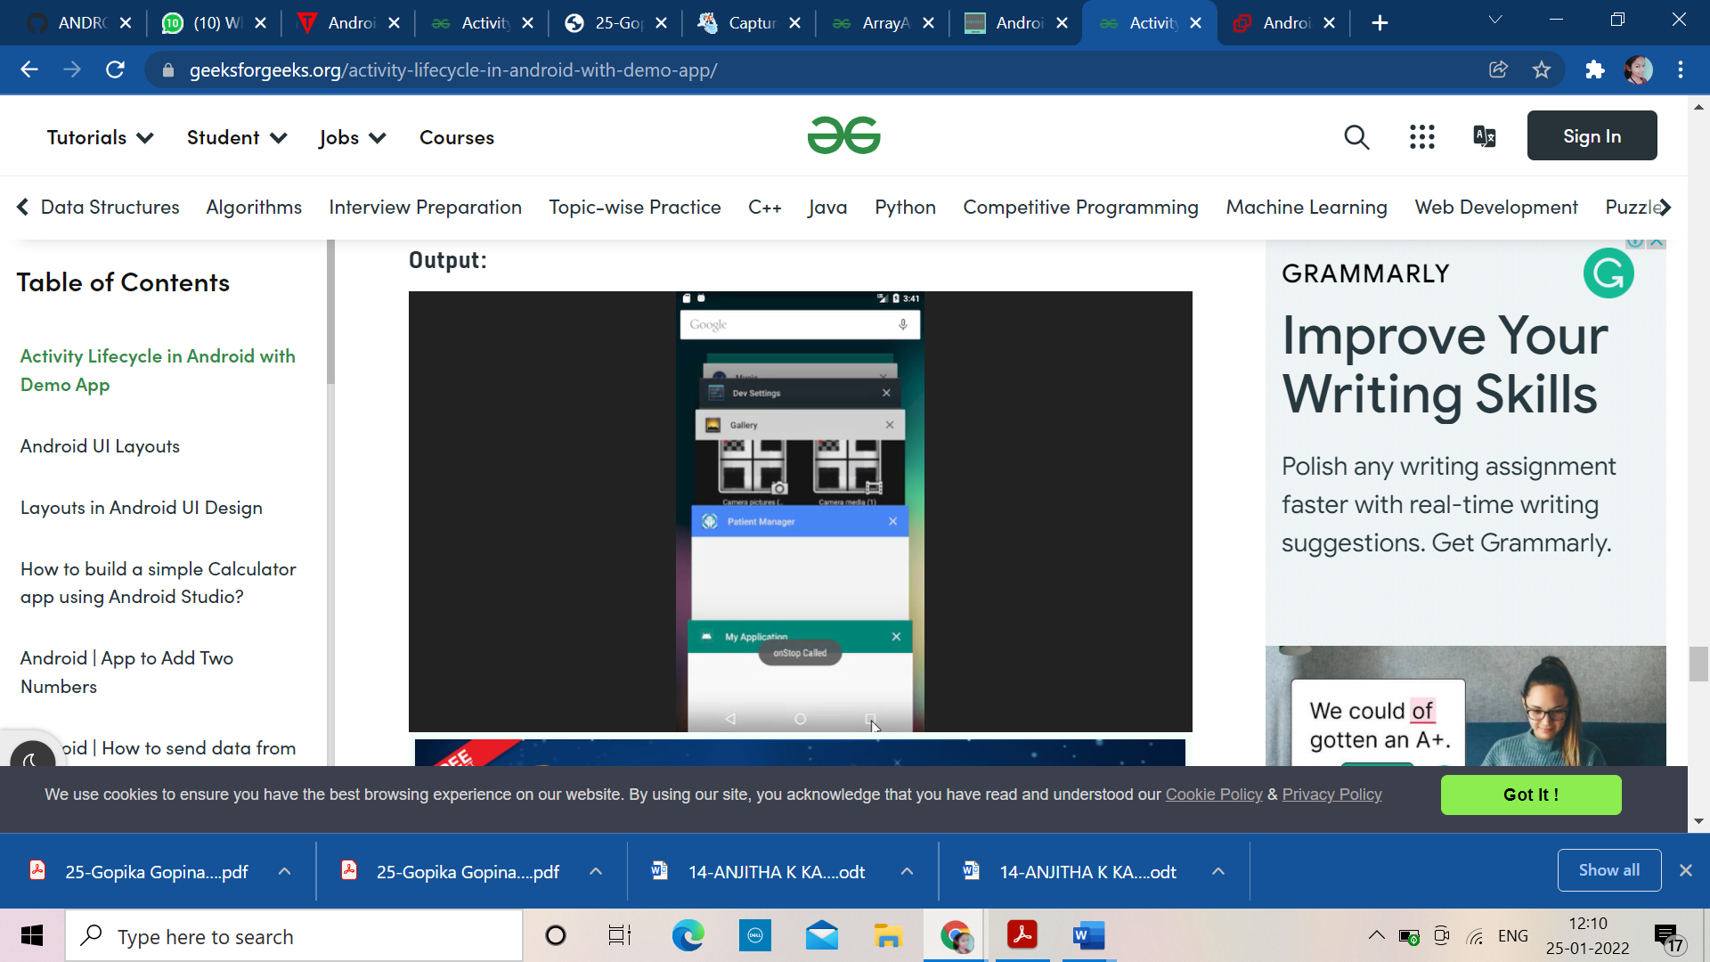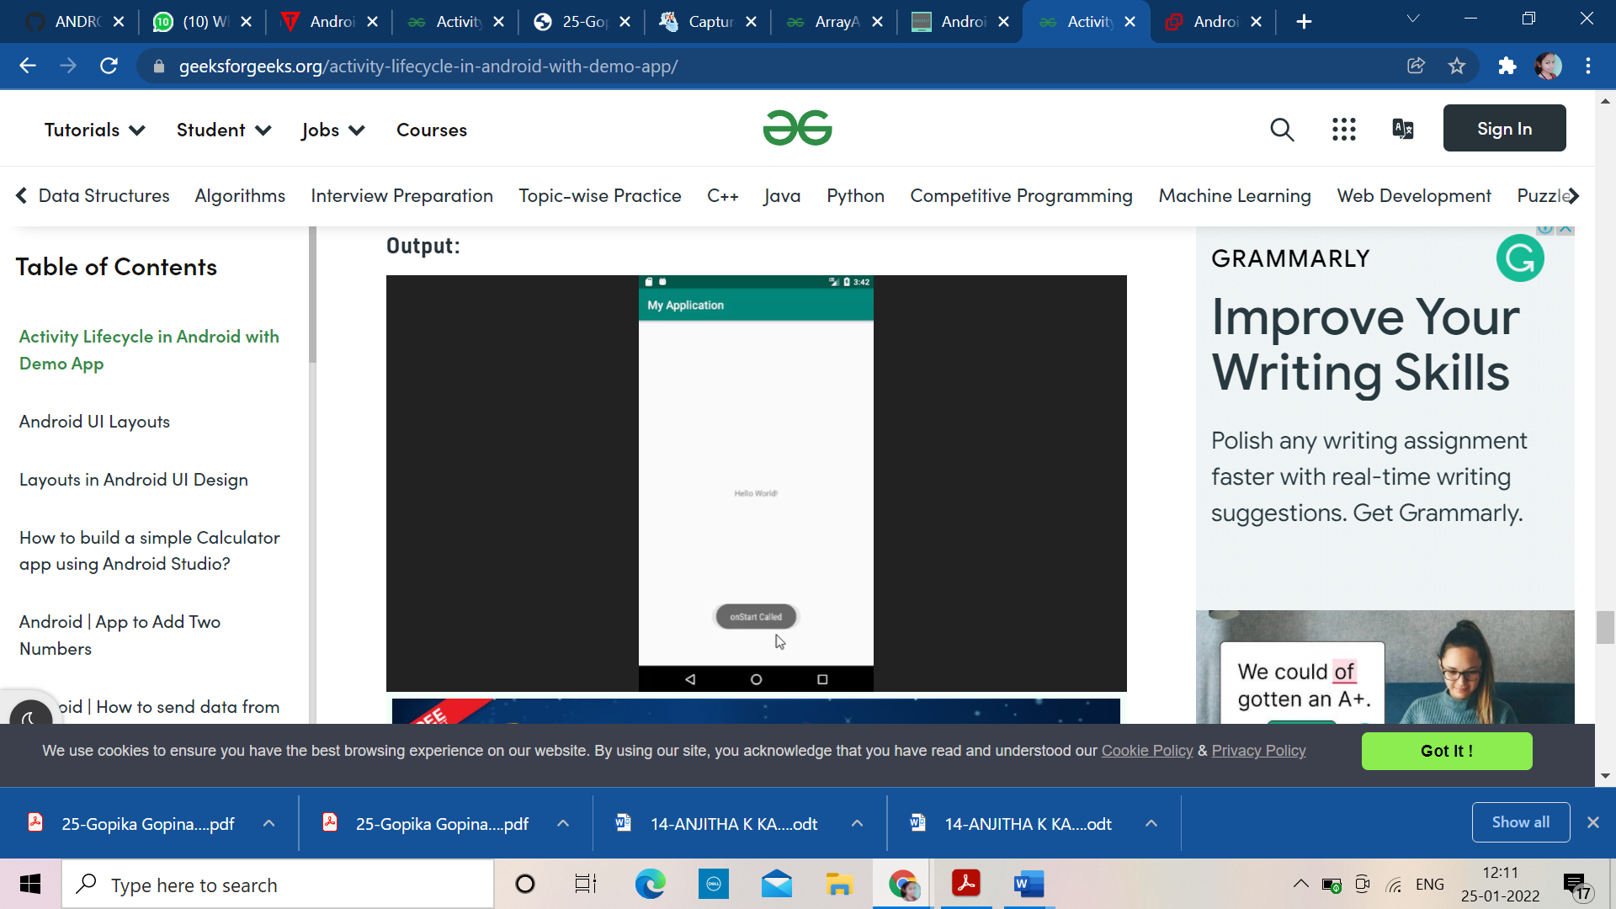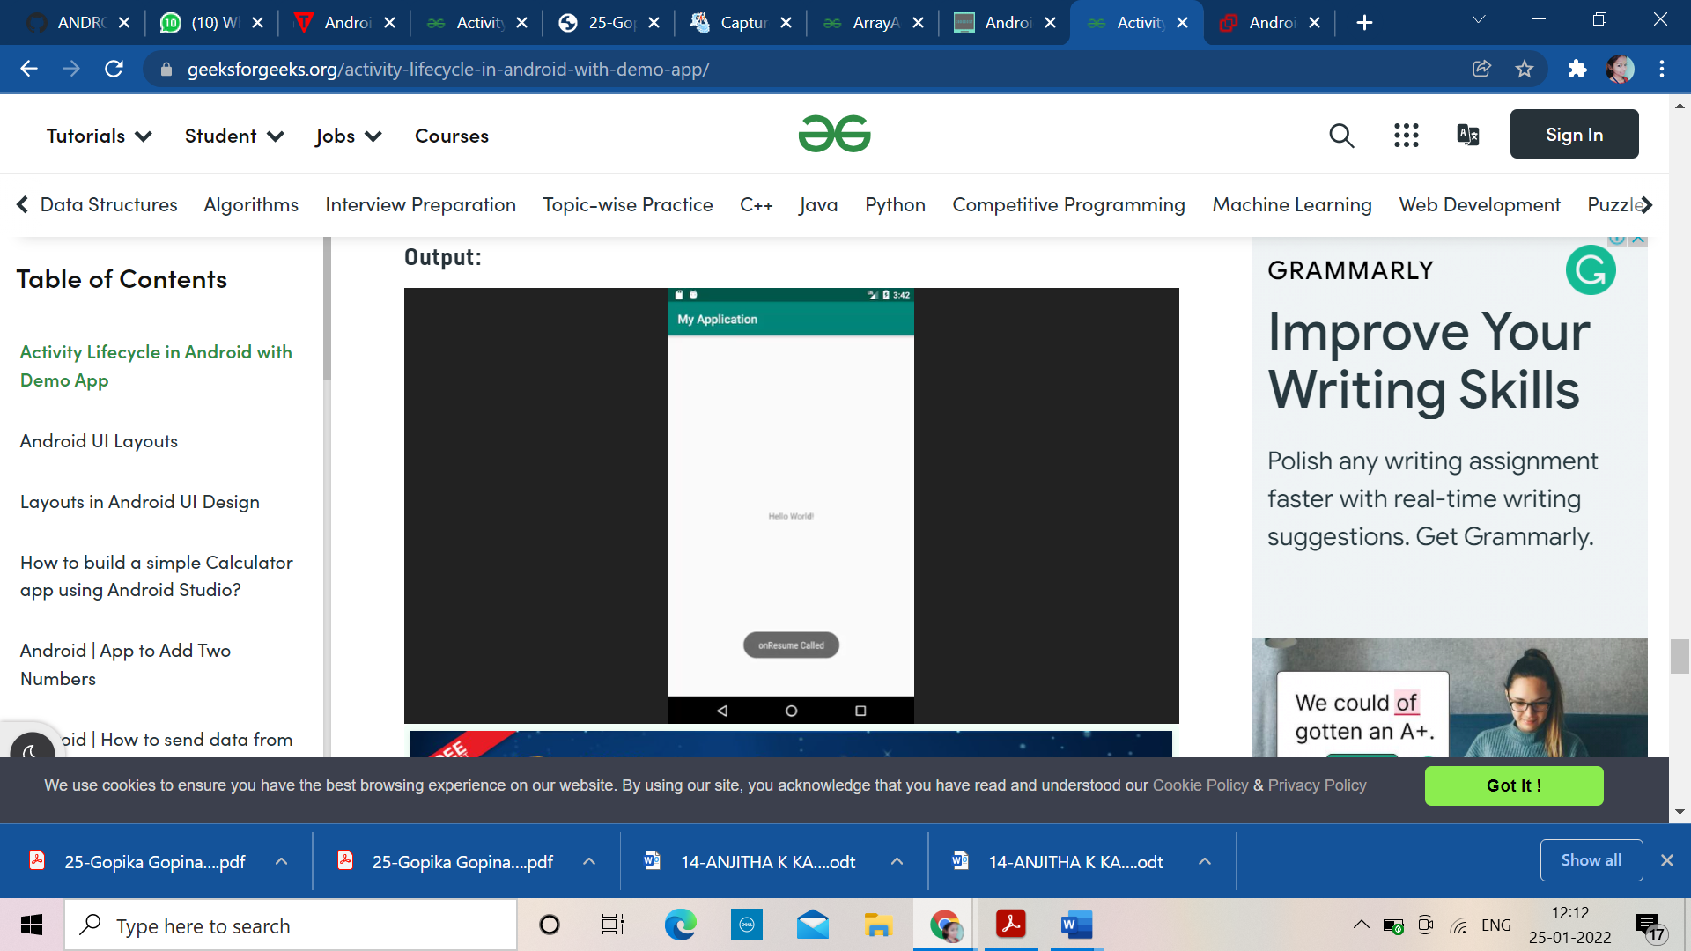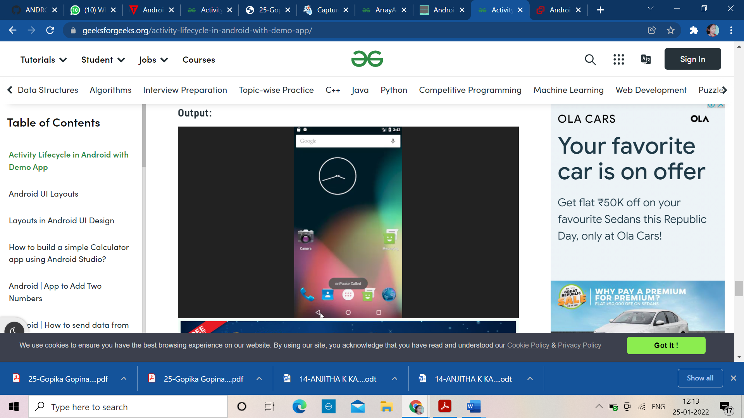

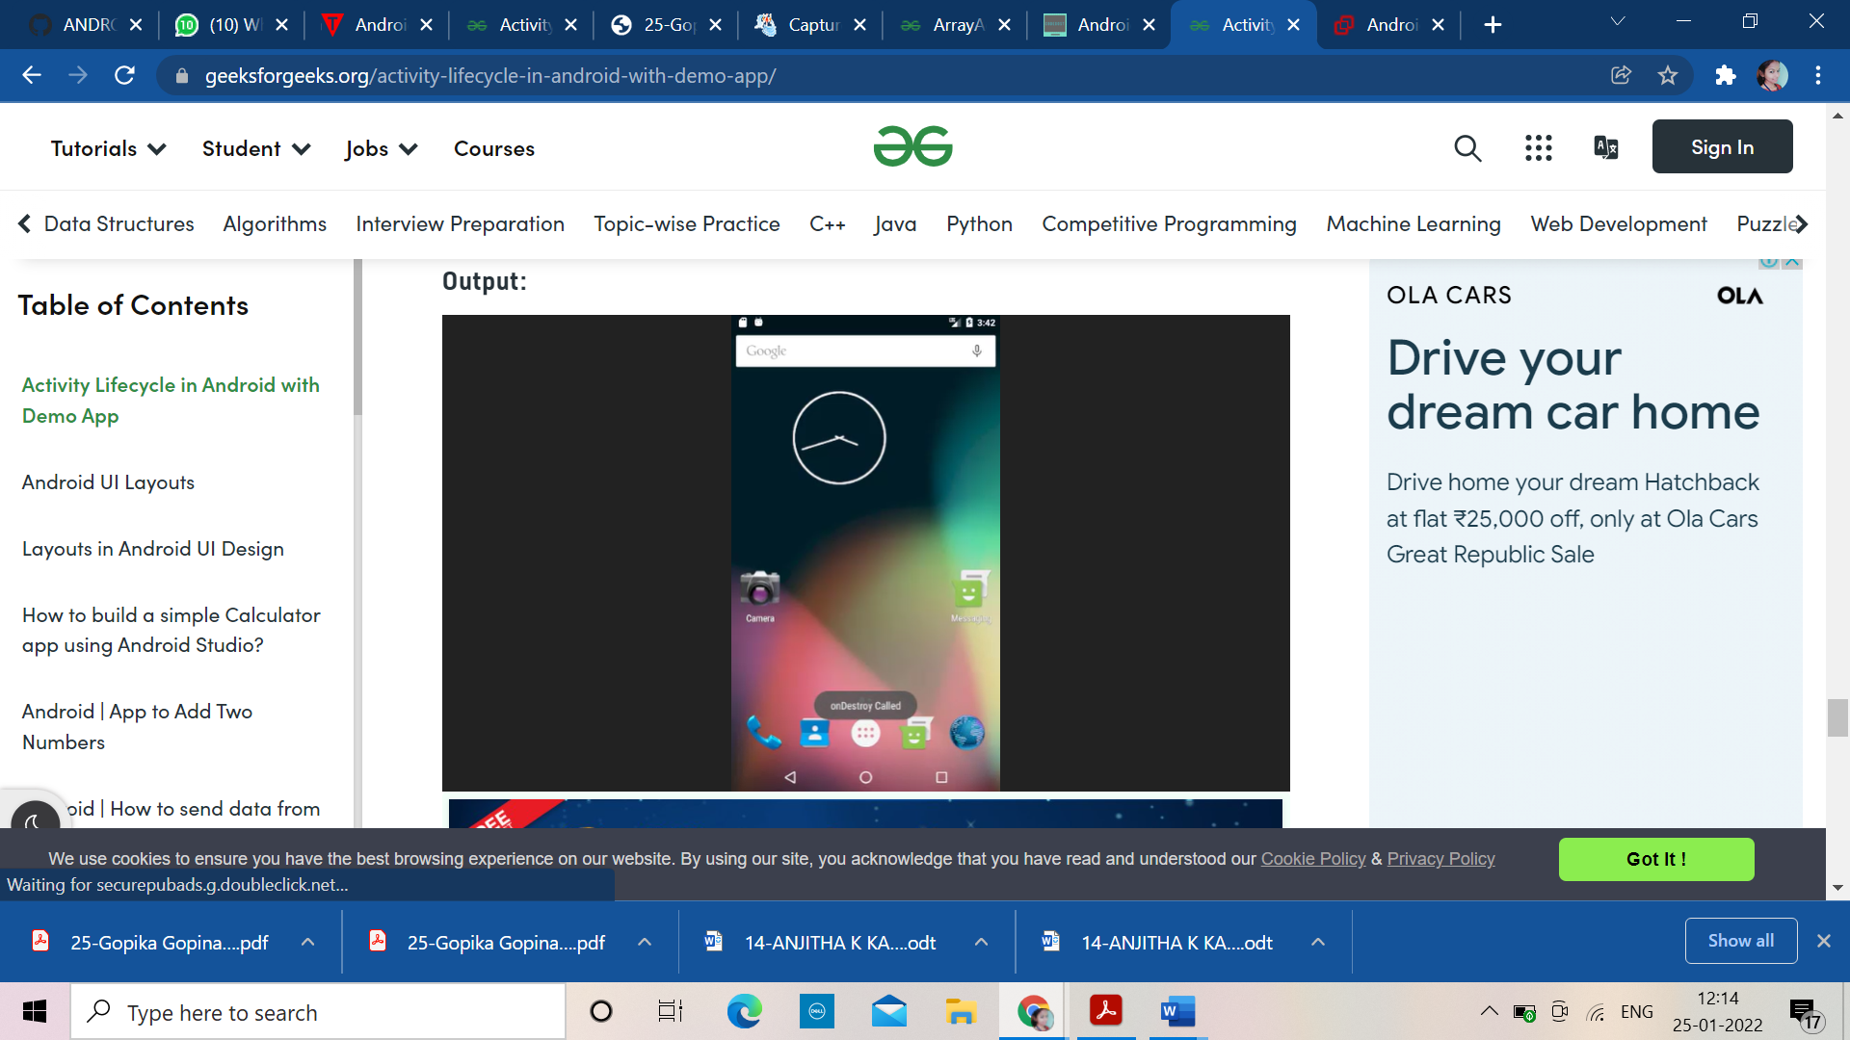

**Q:5) taking camera and saving the picture**.

**PROGRAM**

**ANDROID MANIFEST**

<manifest xmlns:android="http://schemas.android.com/apk/res/android"

package="com.chhavi.uploadingandviewimage"

android:versionCode="1"

    android:versionName="1.0" >

  <uses-permission android:name="android.permission.CAMERA" />

  <uses-feature android:name="android.hardware.camera" />

  <uses-feature android:name="android.hardware.camera.autofocus" />

  <uses-permission android:name="android.permission.WRITE_EXTERNAL_STORAGE" />

  <uses-sdk

      android:minSdkVersion="7"

      android:targetSdkVersion="16" />

  <application

      android:allowBackup="true"

      android:icon="@drawable/ic_launcher"

      android:label="@string/app_name"

      android:theme="@style/AppTheme" >

    <activity

       android:name="com.chhavi.uploadingandviewimage.MainActivity"

        android:label="@string/app_name" >

      <intent-filter>

        <action android:name="android.intent.action.MAIN" />

        <category android:name="android.intent.category.LAUNCHER" />

      </intent-filter>

    </activity>

  </application>

</manifest>

**XML**

<LinearLayout xmlns:android="http://schemas.android.com/apk/res/android"

              xmlns:tools="http://schemas.android.com/tools"

              android:id="@+id/LinearLayout1"

              android:layout_width="match_parent"

              android:layout_height="match_parent"

              android:orientation="vertical"

              android:padding="10dp" >

  <LinearLayout

          android:layout_width="match_parent"

          android:layout_height="wrap_content"

          android:gravity="center"

          android:padding="5dp" >

    <Button

            android:id="@+id/btnSelectPhoto"

            android:layout_width="match_parent"

            android:layout_height="wrap_content"

            android:text="Select Photo" />

  </LinearLayout>

  <LinearLayout

          android:layout_width="match_parent"

          android:layout_height="match_parent"

          android:orientation="vertical"

          android:padding="10dp" >

    <ImageView

            android:id="@+id/viewImage"

            android:layout_width="match_parent"

            android:layout_height="wrap_content"

            android:src="@drawable/camera" />

  </LinearLayout>

</LinearLayout>

**JAVA**

**package** com.chhavi.uploadingandviewimage;

**import** android.app.AlertDialog;

**import** android.content.DialogInterface;

**import** android.content.Intent;

**import** android.database.Cursor;

**import** android.graphics.Bitmap;

**import** android.graphics.BitmapFactory;

**import** android.net.Uri;

**import** android.os.Bundle;

**import** android.app.Activity;

**import** android.os.Environment;

**import** android.provider.MediaStore;

**import** android.util.Log;

**import** android.view.Menu;

**import** android.view.View;

**import** android.widget.Button;

**import** android.widget.ImageView;

**import** java.io.File;

**import** java.io.FileNotFoundException;

**import** java.io.FileOutputStream;

**import** java.io.IOException;

**import** java.io.OutputStream;

**public** **class** MainActivity **extends** Activity {

    ImageView viewImage;

    Button b;

    @Override

**protected** **void** onCreate(Bundle savedInstanceState) {

**super**.onCreate(savedInstanceState);

        setContentView(R.layout.activity_main);

        b=(Button)findViewById(R.id.btnSelectPhoto);

        viewImage=(ImageView)findViewById(R.id.viewImage);

        b.setOnClickListener(**new** View.OnClickListener() {

            @Override

**public** **void** onClick(View v) {

                selectImage();

            }

        });

    }

    @Override

**public** **boolean** onCreateOptionsMenu(Menu menu) {

        // Inflate the menu; this adds options to the action bar if it is present.

        getMenuInflater().inflate(R.menu.main, menu);

**return** **true**;

    }

**private** **void** selectImage() {

**final** CharSequence[] options = { "Take Photo", "Choose from Gallery","Cancel" };

        AlertDialog.Builder builder = **new** AlertDialog.Builder(MainActivity.**this**);

        builder.setTitle("Add Photo!");

        builder.setItems(options, **new** DialogInterface.OnClickListener() {

            @Override

**public** **void** onClick(DialogInterface dialog, **int** item) {

**if** (options[item].equals("Take Photo"))

                {

                    Intent intent = **new** Intent(MediaStore.ACTION_IMAGE_CAPTURE);

                    File f = **new** File(android.os.Environment.getExternalStorageDirectory(), "temp.jpg");

                    intent.putExtra(MediaStore.EXTRA_OUTPUT, Uri.fromFile(f));

                    startActivityForResult(intent, 1);

                }

**else** **if** (options[item].equals("Choose from Gallery"))

                {

                    Intent intent = **new**   Intent(Intent.ACTION_PICK,android.provider.MediaStore.Images.Media.EXTERNAL_CONTENT_URI);

                    startActivityForResult(intent, 2);

                }

**else** **if** (options[item].equals("Cancel")) {

                    dialog.dismiss();

                }

            }

        });

        builder.show();

    }

    @Override

**protected** **void** onActivityResult(**int** requestCode, **int** resultCode, Intent data) {

**super**.onActivityResult(requestCode, resultCode, data);

**if** (resultCode == RESULT_OK) {

**if** (requestCode == 1) {

                File f = **new** File(Environment.getExternalStorageDirectory().toString());

**for** (File temp : f.listFiles()) {

**if** (temp.getName().equals("temp.jpg")) {

                        f = temp;

**break**;

                    }

                }

**try** {

                    Bitmap bitmap;

                    BitmapFactory.Options bitmapOptions = **new** BitmapFactory.Options();

                    bitmap = BitmapFactory.decodeFile(f.getAbsolutePath(),

                            bitmapOptions);

                    viewImage.setImageBitmap(bitmap);

                    String path = android.os.Environment

                            .getExternalStorageDirectory()

                            + File.separator

                            + "Phoenix" + File.separator + "default";

                    f.delete();

                    OutputStream outFile = **null**;

                    File file = **new** File(path, String.valueOf(System.currentTimeMillis()) + ".jpg");

**try** {

                        outFile = **new** FileOutputStream(file);

                        bitmap.compress(Bitmap.CompressFormat.JPEG, 85, outFile);

                        outFile.flush();

                        outFile.close();

                    } **catch** (FileNotFoundException e) {

                        e.printStackTrace();

                    } **catch** (IOException e) {

                        e.printStackTrace();

                    } **catch** (Exception e) {

                        e.printStackTrace();

                    }

                } **catch** (Exception e) {

                    e.printStackTrace();

                }

            } **else** **if** (requestCode == 2) {

                Uri selectedImage = data.getData();

                String[] filePath = { MediaStore.Images.Media.DATA };

                Cursor c = getContentResolver().query(selectedImage,filePath, **null**, **null**, **null**);

                c.moveToFirst();

**int** columnIndex = c.getColumnIndex(filePath[0]);

                String picturePath = c.getString(columnIndex);

                c.close();

                Bitmap thumbnail = (BitmapFactory.decodeFile(picturePath));

                Log.w("path of image from gallery......******************.........", picturePath+"");

                viewImage.setImageBitmap(thumbnail);

            }

        }

    }

}

**OUTPUT**

